

ASSET VERIFICATION AND RECORDING TOOL KIT


Plot 31, Bukoto Street
P.O Box 7657, Kampala, Uganda
+256 (0) 39 2000216/0772525235
email: cpa@cpa.ug

www.cpa.com

August to September 2026

VERIFICATION DETAILS

NAME OF THE REGION: | WESTERN
SUB-REGION: | TOORO
Name of Local Government | NTOROKO
VERIFIER PARTICULARS
Full name | ZALWANGO MARIA, NASSEJJE NADIA, NABBOSA SUMAYA
Contact/ email and Telephone
Supervisor/ Sub team leader | 0751977570, 0754884004, 0708098456
Name | DEPAUL MBONIGABA
Contact | 0788483159
Date of submission

SCHOOL VERIFICATION CHECKLIST

SCHOOL INTERVIEW/DISCUSSION GUIDE

Name of school: NOMBE SEED SECONDARY SCHOOL

1a | Does the Facility have a record of all assets provided under UgIFT.  (Obtain a record and verify if it has the costs and numbers supplied | Yes, but it has no costs.
1b | If Not ask how many were supplied and when. | 426. he is not sure of the exact date.

2 | How does this facility Maintain (repair/service/replace) the assets provided under Ugift

The facility uses the school budget to repair/service/replace all the assets provided under UgIFT.

3 | Does the facility take regular record about functionality/ or breakdown of the assets provided?  Nonfunctional/ working, and reasons for non-functionality. | Yes. The desks were broken (some)

4 | How has the UgIFT support helped in service delivery in the area, any issues, challenges and any recommendations for better program implementation.

- Source of employment opportunities to the community.
- Provides education as a service to the community which has been led to its development.
Recommendations: If possible Ugift should provide more laboratory equipments and the ICT equiments for the students.
Also they are requesting for a boarding section to be constructed because a lot of children come from very far so they reach at school very late.

PROCEED TO VERIFICATION AFTER THIS DISCUSSION

SCHOOL FURNITURE
(School Desks, Office chairs, Laboratory stools, Book shelves)

Name of LG: NTOROKO DISTRICT Name of SCHOOL: NOMBE SEED SECONDARY SCHOOL

Equipment/ Item | Department | Asset Number | Item  Description | Life in Months | Tag Number ( engrave no.) | Date Of Pur | Date Placed In Service | Recoverable cost | Cost | Acc Dep Cost | Net Book Value | Ytd Deprn | Equipment status | Remarks
School desks | Education |  | Wooden and brown in colour |  |  |  |  |  |  |  |  |  | Two desks  were  faulty and  the rest were  in good  condition | They are in use.  100 desks received.
Office chairs | Education |  | Brown in colour. 9 were black with wheels. Some were maroon in colour with spongy seats and metallic seats. |  |  |  |  |  |  |  |  |  | Good condition | All are in use.  They are 161
Labaratory stools | Education |  | Brown in colour with metallic stands. |  |  |  |  |  |  |  |  |  | Good condition | They are all in use.  They are 120.
Bookshelves | Education |  |  |  |  |  |  |  |  |  |  |  |  | Were not constructed.
Tables | Education |  | Wooden and brown in colour |  |  |  |  |  |  |  |  |  | Good condition | They are all in use. They are 26 tables.

ICT ITEMS TO VERIFY
(Desktop Computer, Server Processor, Network Switch 24 Port, Multipurpose Printer, UPS, Projector, Air Conditioners, Server, CCTV Camera)

Name of LG…………………………………………………………………………… Name of SCHOOL………………………….………………………………………

Equipment/ Item | Department | Asset Number | Item  Description | Life in Months | Tag Number ( engrave no.) | Date Of Pur | Date Placed In Service | Recoverable cost | Cost | Acc Dep Cost | Net Book Value | Ytd Deprn | Equipment status | Remarks
ICT ITEMS |  |  |  |  |  |  |  |  |  |  |  |  |  | They never received any ICT items

BUILDINGS TO VERIFY
(Non- Residential and Residential, Kitchen, Toilets/Pit latrine Water tanks, Fences etc.)

Name of LG…………………………………………………………………………… Name of SCHOOL………………………….………………………………………

Equipment/ Item | Department | Asset Number | Item  Description | Life in Months | Tag Number ( engrave no.) | Date Of Pur | Date Placed In Service | Recoverable cost | Cost | Acc Dep Cost | Net Book Value | Ytd Deprn | Equipment status | Remarks
Non residential | Education |  | Painted cream and white |  |  |  |  |  |  |  |  |  | Good condition | They are in use. They are seven in number.
Residential | Education |  | Painted cream and white |  |  |  |  |  |  |  |  |  | Good condition | They are all in use.  They are 3 in number.
Kitchen | Education |  |  |  |  |  |  |  |  |  |  |  |  | Not built.
Toilets | Education |  |  |  |  |  |  |  |  |  |  |  |  | Not constructed
Pit latrine | Education |  | They are painted cream and white. |  |  |  |  |  |  |  |  |  | Good condition | They are all in use.  They are all in use.  3 are for residential and 3 are not for residential.
Water tanks | Education |  | They are black in colour |  |  |  |  |  |  |  |  |  | One is faulty and two are working. | Two in use. They re three. Not constructed.
Fence |  |  |  |  |  |  |  |  |  |  |  |  |  | Not constructed.
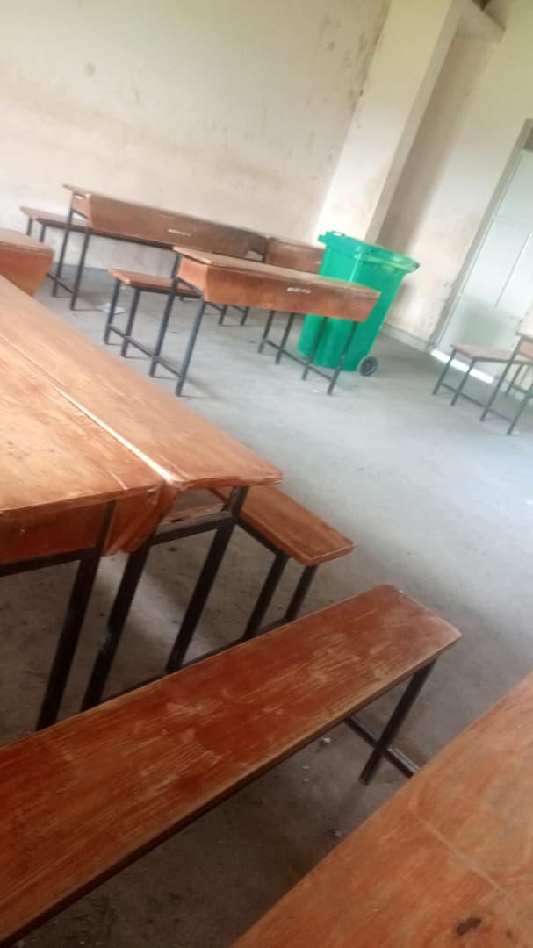
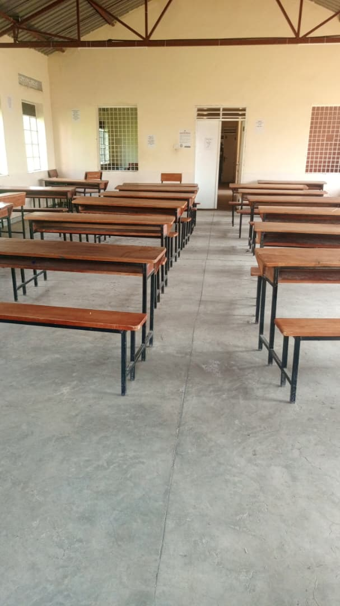
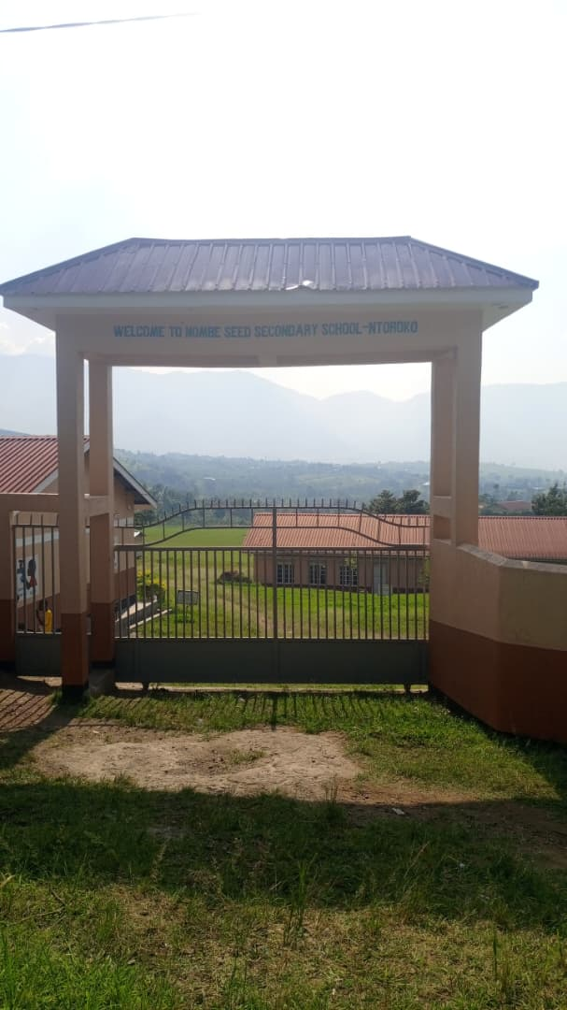
Main gate Desks Classroom

Compound Computer room Faulty tank
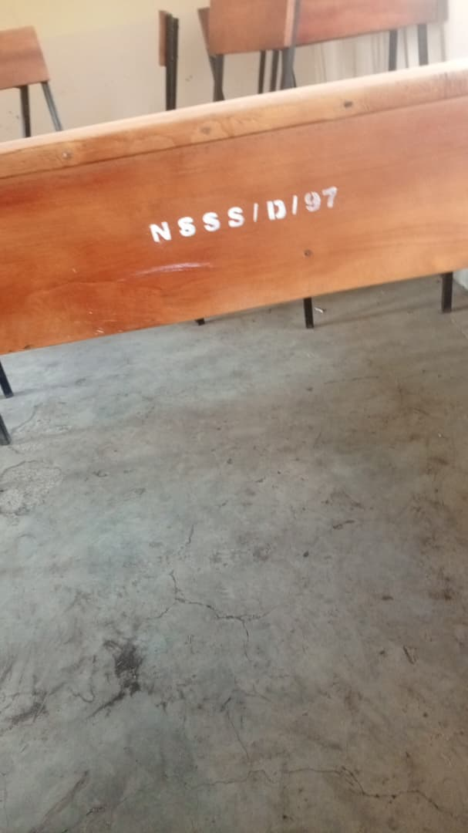
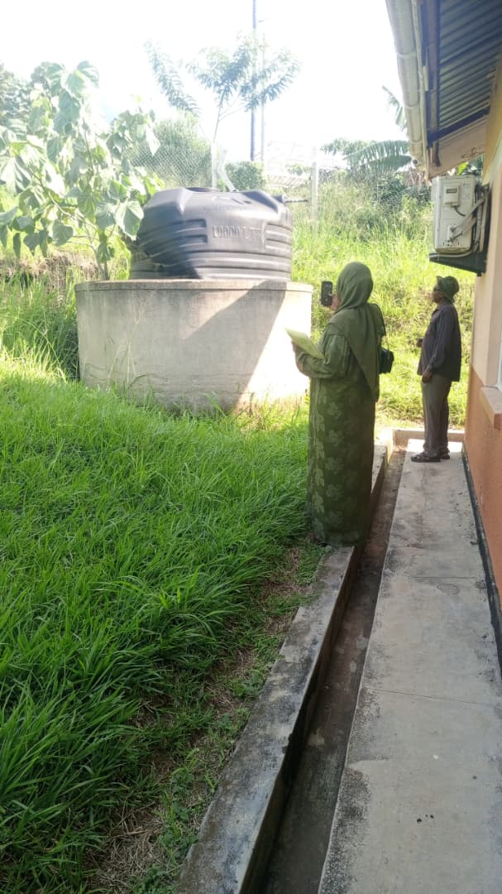
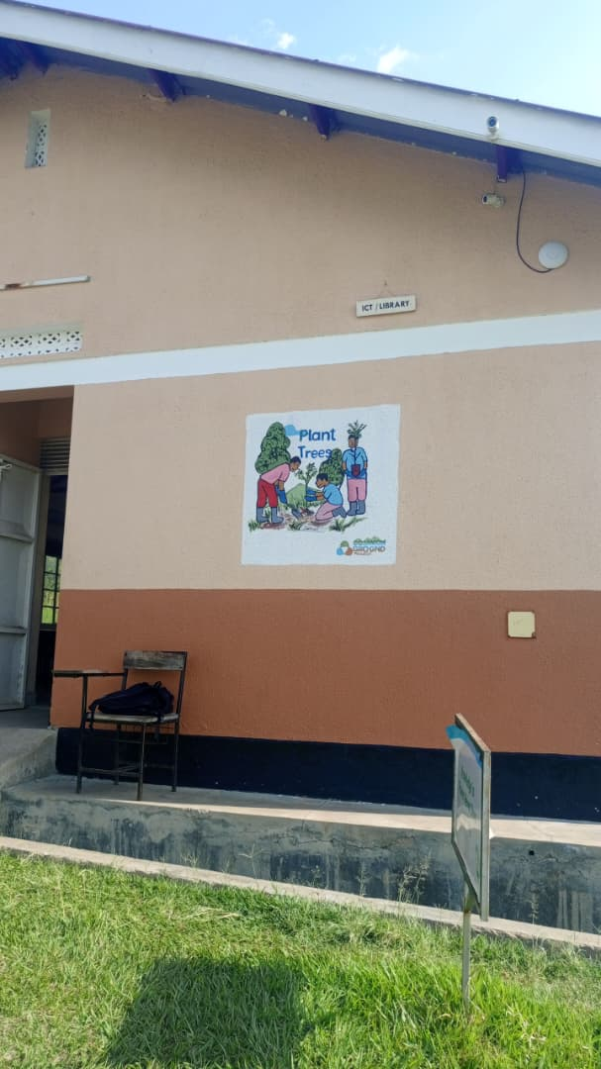
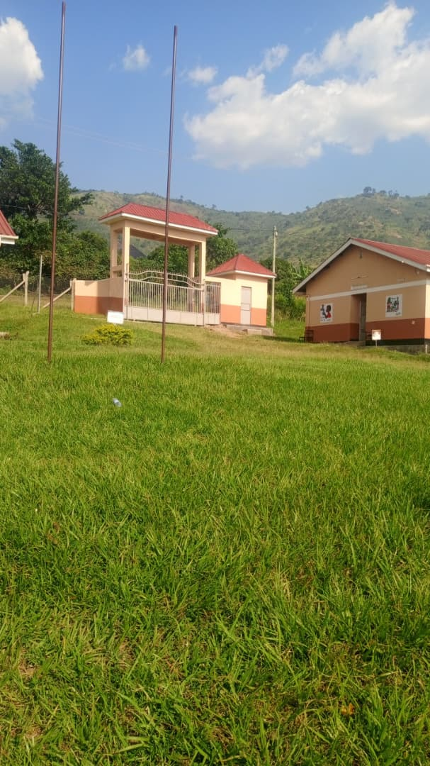
Compound

Engraved desk

